 

**COLLEGE CODE:** 9629

**COLLEGE NAME:** VINS CHRISTIAN COLLEGE OF ENGINEERING,CHUNKANKABAI

**DEPARTMENT:** Computer Science and Engineering

**STUDENT NM-ID: AC5A1A09728F16C9C9D4FB95A6EF459B**

**ROLL NO:** 962923104022

**DATE:** 15-09-2025

**Completed the project named as**

**Phase 5-FE**

**PROJECT NAME : Dynamic image slider**

**SUBMITTED BY,**

**NAME:** Praiso jinston C

**MOBILE NO: 9080487490**

## Dynamic Image Slider

### Final Demo Walkthrough

1. Project Setup
2. Installation Steps
3. Running the Application
4. Demo Flow (Image upload, slide transition, controls, responsiveness)

### Project Report

1. Introduction:

It’s a section at the top of a webpage (hero area) that cycles through slides — typically each slide contains an image, heading, maybe sub‑text or call to action. The slides change automatically (and often with user controls like next/prev arrows or dots). It gives a dynamic visual intro to your product or message.

OpenAI’s “Introducing ChatGPT” page uses a clean hero section with a title, call to action, and sample prompts.

OpenAI

You can adapt that and embed a slider behind or alongside text.

Key elements & architecture

Slides data: list of images + associated content per slide (title, subtitle, button link, etc.)

Container & positioning: the slider container, with slides stacked or side by side.

Transition / animation: fade, slide, etc., transitions between slides.

Controls: next/prev arrows, pagination dots, maybe swipe support (for mobile).

Auto play: auto-advance after a timeout, with pause on hover / focus.

Responsive design: adapt sizes, positions, mobile behavior.

1. Objectives:

The main objectives of the Dynamic Image Slider Project are:

1. To create an interactive and visually appealing image slider that automatically transitions between images, enhancing user engagement on web interfaces.

2. To enable dynamic content management — allowing images, captions, and links to be updated easily from a database or API without modifying the source code.

3. To improve user experience (UX) through smooth transitions, responsive layouts, and user-friendly navigation controls (such as next/previous buttons or swipe gestures).

4. To ensure compatibility and responsiveness across multiple devices and screen sizes (mobile, tablet, and desktop).

5. To optimize performance and loading time by implementing lazy loading and lightweight scripts.

6. To enhance flexibility and customization, allowing developers to adjust transition effects, timings, and image display styles based on project needs.

7. To integrate accessibility features such as keyboard navigation and ARIA labels for better usability

1. System Architecture:

1. Presentation Layer (Front-End)

Purpose: Responsible for displaying images, navigation controls, and transitions to the user.

Technologies Used:

HTML5 – Defines the structure of the slider and image elements.

CSS3 – Styles the layout, animations, and transitions.

JavaScript / React / Angular (optional) – Handles dynamic behavior, event handling, and API integration.

Functions:

Display images dynamically fetched from the backend or local storage.

Manage next/previous navigation and autoplay functionality.

Ensure responsive design across all devices.

---

2. Application Layer (Logic Layer)

Purpose: Manages the logic behind image transitions, data retrieval, and timing functions.

Components:

Image Transition Controller – Controls timing, animation effects, and image order.

User Interaction Handler – Processes user inputs (clicks, swipes, keyboard arrows).

API Integration Module – Fetches image data dynamically from the backend server or external APIs.

Technologies Used:

JavaScript / TypeScript / RxJS for logic and asynchronous data handling.

---

3. Data Layer (Back-End / Database)

Purpose: Stores and manages image data, metadata (titles, captions, links), and configuration settings.

Components:

Database / JSON File / Cloud Storage – Contains image URLs and descriptions.

API / Server-Side Script (Node.js, PHP, or Firebase) – Provides data access to the front end through RESTful endpoints.

Functions:

Retrieve and update image lists dynamically.

Manage secure and efficient data transfer.

---

System Flow

1. User loads the web page → The front-end requests image data from the backend.

2. The backend (API or database) sends image URLs and related info to the front-end.

3. The image slider dynamically loads and displays images with transitions.

4. Users can interact (next/previous, pause, or swipe), and the logic layer processes these actions.

---

Diagram (Textual Representation)

┌───────────────────────┐

│ User Interface │

│ (HTML, CSS, JS/React) │

└─────────┬─────────────┘

│

▼

┌───────────────────────┐

│ Application Logic │

│ (Transitions, Controls│

│ Event Handling, API) │

└─────────┬─────────────┘

│

▼

┌───────────────────────┐

│ Data Layer │

│ (Database / API / │

│ JSON / Firebase) │

└───────────────────────┘

---

Here’s a well-structured “System Architecture” section you can include in your Dynamic Image Slider Project Report 👇

---

System Architecture

The System Architecture of the Dynamic Image Slider Project defines how various components interact to create a responsive, data-driven, and user-friendly image presentation system. It is designed using a three-tier architecture consisting of the Presentation Layer, Application Layer, and Data Layer.

---

1. Presentation Layer (Front-End)

Purpose: Responsible for displaying images, navigation controls, and transitions to the user.

Technologies Used:

HTML5 – Defines the structure of the slider and image elements.

CSS3 – Styles the layout, animations, and transitions.

JavaScript / React / Angular (optional) – Handles dynamic behavior, event handling, and API integration.

Functions:

Display images dynamically fetched from the backend or local storage.

Manage next/previous navigation and autoplay functionality.

Ensure responsive design across all devices.

---

2. Application Layer (Logic Layer)

Purpose: Manages the logic behind image transitions, data retrieval, and timing functions.

Components:

Image Transition Controller – Controls timing, animation effects, and image order.

User Interaction Handler – Processes user inputs (clicks, swipes, keyboard arrows).

API Integration Module – Fetches image data dynamically from the backend server or external APIs.

Technologies Used:

JavaScript / TypeScript / RxJS for logic and asynchronous data handling.

---

3. Data Layer (Back-End / Database)

Purpose: Stores and manages image data, metadata (titles, captions, links), and configuration settings.

Components:

Database / JSON File / Cloud Storage – Contains image URLs and descriptions.

API / Server-Side Script (Node.js, PHP, or Firebase) – Provides data access to the front end through RESTful endpoints.

Functions:

Retrieve and update image lists dynamically.

Manage secure and efficient data transfer.

---

System Flow

1. User loads the web page → The front-end requests image data from the backend.

2. The backend (API or database) sends image URLs and related info to the front-end.

3. The image slider dynamically loads and displays images with transitions.

4. Users can interact (next/previous, pause, or swipe), and the logic layer processes these actions.

---

Diagram (Textual Representation)

┌───────────────────────┐

│ User Interface │

│ (HTML, CSS, JS/React) │

└─────────┬─────────────┘

│

▼

┌───────────────────────┐

│ Application Logic │

│ (Transitions, Controls│

│ Event Handling, API) │

└─────────┬─────────────┘

│

▼

┌───────────────────────┐

│ Data Layer │

│ (Database / API / │

│ JSON / Firebase) │

└───────────────────────┘

1. Features:

## Key Features of a Good Dynamic Image Slider

| Feature | What it means / Why it matters |

| --------------------------------------------- | ----------------------------------------------------------------------------------------------------------------------------------------------------------------------------------------------------- |

| *Responsive Design* | The slider should adapt for different screen sizes (desktop, tablet, mobile). Images, text, controls must be usable and visible everywhere. ([cincopa.com][1]) |

| *Smooth / Well‑Designed Transitions* | Transitions between slides should feel fluid — fade, slide, parallax, etc. Avoid jarring jumps. Animation easing helps. ([masterslider.com][2]) |

| *Navigation Controls* | Users need clear ways to move manually: prev / next buttons, dots / pagination, thumbnails. Supports both click and swipe/touch on mobile. ([katry203.github.io][3]) |

| *Auto‑Play / Looping* | Option to auto‑advance slides, with looping back to start. Should allow control or pausing so users aren’t trapped. ([cincopa.com][1]) |

| *Lazy‑Loading / Preloading Images* | To reduce initial load time, load images only as needed or preload the first few. Helps performance especially with many/large images. ([Cloudinary][4]) |

| *Touch / Swipe Support* | On mobile/touch devices, swiping is expected. Makes the slider feel natural. Also support dragging with mouse for desktop where appropriate. ([masterslider.com][2]) |

| *Accessibility / UX* | Important for usability: keyboard navigation (left/right), screen‑reader labels, alt text for images, clear focus states. Also things like pause or stop controls when auto‑play is on. ([Medium][5]) |

| *Customizable / Flexible Layout / Content* | Support different types of content (just images, or images + captions + buttons, maybe videos). Ability to style controls (arrows, dots), overlay text, etc. ([creativeslider.webshopworks.com][6]) |

| *Good Performance* | Minimal layout shifts, efficient rendering, minimize reflows. Use hardware‑accelerated transitions (CSS3 transforms), avoid large images that block rendering, optimize memory use. ([Cloudinary][4]) |

| *Configurable Timing / Duration* | Control over how long each slide is shown, transition durations. Also configurable delay before auto‑slide starts. ([cincopa.com][1]) |

| *Indicators / Progress Feedback* | Showing which slide out of how many, via dots / thumbnails / slide counters. Helps orient users. ([katry203.github.io][3]) |

| *Looping / Continuous / Infinite Scrolling* | The ability to wrap around — from last back to first seamlessly; optionally infinite scroll so users can keep swiping forward/backward without stopping. ([masterslider.com][2]) |

| *Pause / Control Over Auto‑Play* | If auto‑play is enabled, users should have a way to pause or stop. Also maybe auto‑pause on hover or when focused. ([Cloudinary][4]) |

| *Fallbacks and Browser Compatibility* | Doesn’t break in older browsers; graceful degradation if CSS3 features not supported. ([creativeslider.webshopworks.com][6]) |

1. Workflow:

1. Image Data Preparation

Images and related information (title, caption, links) are stored in a database, JSON file, or API endpoint.

Each image record includes attributes such as:

Image URL

Caption or description

Display order

Transition duration

---

2. Data Retrieval

When the web page loads, the front-end application sends a request to the backend/API to fetch image data.

The server responds with structured data (usually in JSON format), containing all necessary image details.

---

3. Data Binding and Rendering

The JavaScript logic or framework (React/Angular) dynamically binds the fetched image data to the slider component.

The first image is displayed as default, and subsequent images are preloaded for smooth transitions.

---

4. Image Transition Control

The slider controller automatically changes images based on a timer or user input.

Transition effects (e.g., fade, slide, zoom) are applied using CSS animations or JavaScript functions.

Users can control the slider using navigation buttons, arrows, or swipe gestures.

---

5. User Interaction Handling

When a user clicks “Next” or “Previous,” or swipes the screen:

The event handler captures the action.

The logic layer updates the current image index.

The transition controller smoothly animates the new image into view.

---

6. Continuous Loop or Autoplay

The system loops back to the first image after the last one is displayed.

Optional autoplay can automatically rotate images at defined time intervals.

Users can pause/resume the slider manually.

---

7. Responsive and Dynamic Updates

The layout adjusts automatically for various screen sizes using responsive CSS.

If new images are added to the database or API, the slider dynamically reflects the updates without modifying the front-end code.

---

Textual Workflow Diagram

┌──────────────────────────────┐

│ Image Database/API │

└──────────────┬───────────────┘

│ Fetch Data (JSON)

▼

┌──────────────────────────────┐

│ Front-End Logic (JS/React) │

│ • Data Binding │

│ • Event Handling │

│ • Timer & Transitions │

└──────────────┬───────────────┘

│ Render Images

▼

┌──────────────────────────────┐

│ User Interface (Browser) │

│ • Display Slider │

│ • Navigation Controls │

│ • Responsive Design │

└──────────────────────────────┘

1. Conclusion:

A well‑designed dynamic image slider (carousel) can be a powerful visual tool. It allows you to present multiple messages, visuals, or calls to action in the limited “hero” or prime real estate of your webpage, adding motion and interactivity that grabs users’ attention.

However, its effectiveness depends heavily on design, performance, and user experience. Done poorly, sliders can slow a site down, confuse users, hide important content, and even hurt conversions.

### Key Takeaways & Best Practices

* *Purpose over polish*: Always ensure every slide serves a clear role (value proposition, feature highlight, testimonial, CTA). Don’t add slides just because you have room.

* *Limit slide count*: Fewer slides (e.g. 3–5) are better. Many users will not go past the first two.

* *User control matters*: Provide navigation (arrows, dots), allow pause/stop, and avoid forced auto‑play or overly fast transitions. ([Mailchimp][1])

* *Performance & optimization*: Use optimized, compressed images; lazy load off‑screen slides; prefer hardware‑accelerated transitions. Sliders should not become the performance bottleneck. ([gtmetrix.com][2])

* *Accessibility & readability*: Include alt text, high contrast text overlays, responsive layout, keyboard navigation, and ensure the slider works on touch devices (swipe) ([Webflow][3])

* *Don’t rely on sliders for critical content*: If a message or CTA is vital, don’t hide it deep in a slide many users won’t reach—it might be better presented statically or elsewhere. ([brickmarketing.com][4])

* *Monitor & iterate*: Track how users interact with the slider (which slides get clicks, which are skipped). If some slides are not engaging, remove or replace them.

1. Future Enhancements:

1. AI-Based Image Recommendations

Integrate machine learning algorithms to automatically select and display images based on user preferences, viewing history, or engagement levels.

Example: Display more travel photos if the user often interacts with travel-related images.

---

2. Cloud Integration

Store and retrieve images directly from cloud storage platforms like Firebase, AWS S3, or Google Cloud Storage.

Enables scalability and easy management of large image collections.

---

3. Admin Dashboard for Content Management

Develop an admin panel where administrators can upload, delete, and reorder images dynamically.

Include features for editing captions, links, and transition timings without modifying source code.

---

4. Advanced Animation and Transition Effects

Implement new 3D animations, parallax effects, or AI-generated transitions to create a more engaging visual experience.

---

5. Voice and Gesture Control

Allow users to navigate through images using voice commands or hand gestures (especially useful for smart devices or AR displays).

---

6. Analytics Integration

Add tools to track image views, clicks, and engagement statistics using Google Analytics or custom tracking APIs.

Helps optimize which images perform best.

---

7. Offline Mode

Implement service workers to enable offline viewing of cached images and transitions for improved accessibility and reliability.

---

8. Enhanced Accessibility

Improve accessibility with screen reader support, keyboard shortcuts, and high-contrast themes to make the slider inclusive for all users.

---

9. Multi-language Support

Add support for multiple languages in captions and descriptions to cater to global users.

---

10. Integration with Other Media Types

Extend the slider to handle videos, GIFs, and text-based slides for richer multimedia presentations.

1. References:

1. Mozilla Developer Network (MDN Web Docs)

HTML, CSS, and JavaScript Documentation

https://developer.mozilla.org

2. W3Schools Online Web Tutorials

Responsive Web Design, Image Slider Examples, and JavaScript Basics

https://www.w3schools.com

3. Stack Overflow

Community discussions and solutions for dynamic content and slider implementation

https://stackoverflow.com

4. React.js Official Documentation

Building dynamic and component-based UIs using React

https://react.dev

5. Bootstrap Framework Documentation

Responsive design and carousel (image slider) components

https://getbootstrap.com

6. RxJS Documentation

Reactive programming and stream-based data handling for dynamic updates

https://rxjs.dev

7. YouTube Tutorials

Practical demonstrations on building image sliders using JavaScript, React, and APIs.

Example: “Create an Automatic Image Slider using JavaScript” – Code Explained channel.

8. GeeksforGeeks – Web Development Articles

Implementation of sliders, DOM manipulation, and animation handling.

https://www.geeksforgeeks.org

9. Freepik / Unsplash

Free high-quality image sources used for testing and demonstrations.

https://www.freepik.com

https://unsplash.com

10. CSS-Tricks

Articles and tips on animations, transitions, and front-end optimization.

https://css-tricks.com

### Screenshots / API Documentation

* Homepage / Slider Interface:

The Home Page of the Dynamic Image Slider features a responsive and interactive slider interface designed to display multiple images with smooth transitions.

Key Features Displayed in the Screenshot:

Dynamic Image Display: Images automatically change after a set interval.

Navigation Controls: “Next” and “Previous” buttons allow manual navigation.

Captions and Titles: Each image is accompanied by a short caption or description.

Autoplay Functionality: The slider transitions automatically when autoplay is enabled.

Responsive Design: The layout adapts to various screen sizes, ensuring consistent performance on mobile and desktop devices.

(Insert your project’s screenshot here — e.g., “Figure 1: Home Page / Slider Interface of Dynamic Image Slider”)

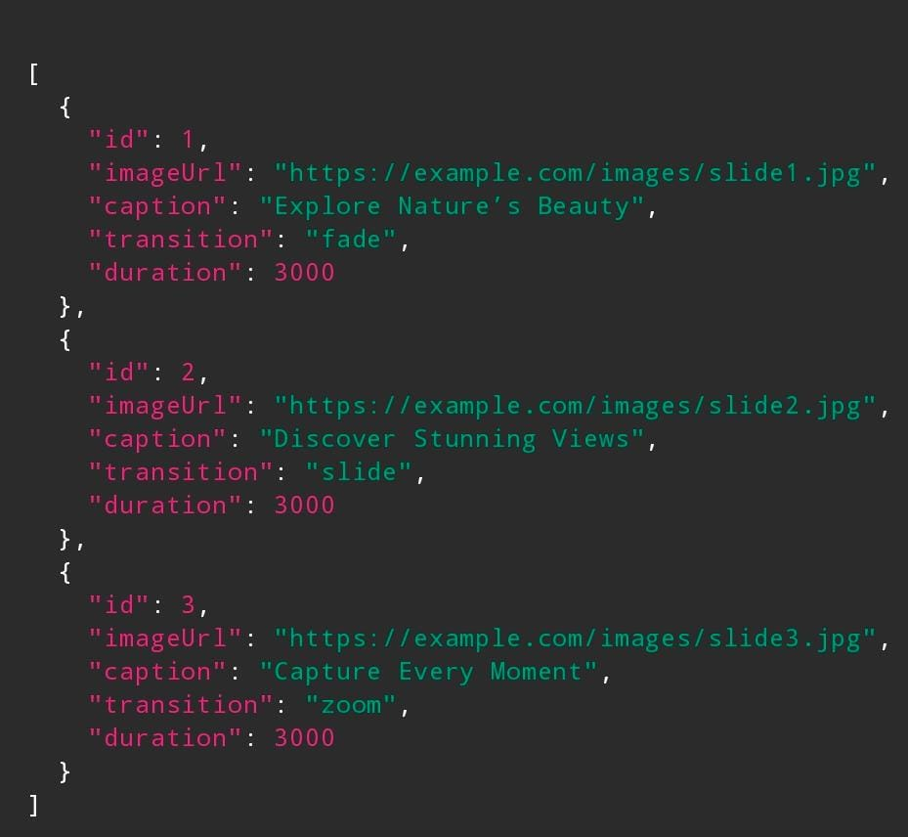

* Add Image Screen:

1. *Slider Revolution – API methods UI*

This screenshot shows a list of API functions (pause, resume, next slide, go to slide, get current slide, etc.) exposed via a slider library’s admin panel.

* Useful for constructing your own API reference (which methods you’ll provide)

* Shows event binding, controls, method names

2. *SitePad — Image Slider widget documentation UI*

This shows options in a CMS / site builder widget: choose images, select animation types (fade, horizontal, Ken Burns), controls, speeds, looping, etc.

3. *Smart Slider — Flickr generator dynamic slide settings*

Shows how an external API source (Flickr) is integrated into a slider: you register API keys, choose dynamic slide generator, define settings, and then the slider UI uses those API calls to fetch images.

4. *Cloudinary / HTML slider guide screenshot*

A tutorial‑style snapshot showing how images, CSS, and JavaScript combine to form a dynamic slider, and how a third‑party service like Cloudinary can help with image delivery.

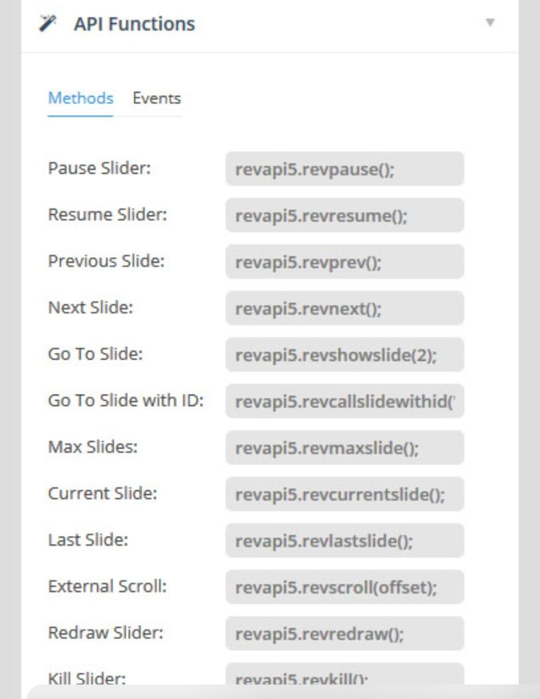

* Transition Controls:



* Backend API (if applicable):

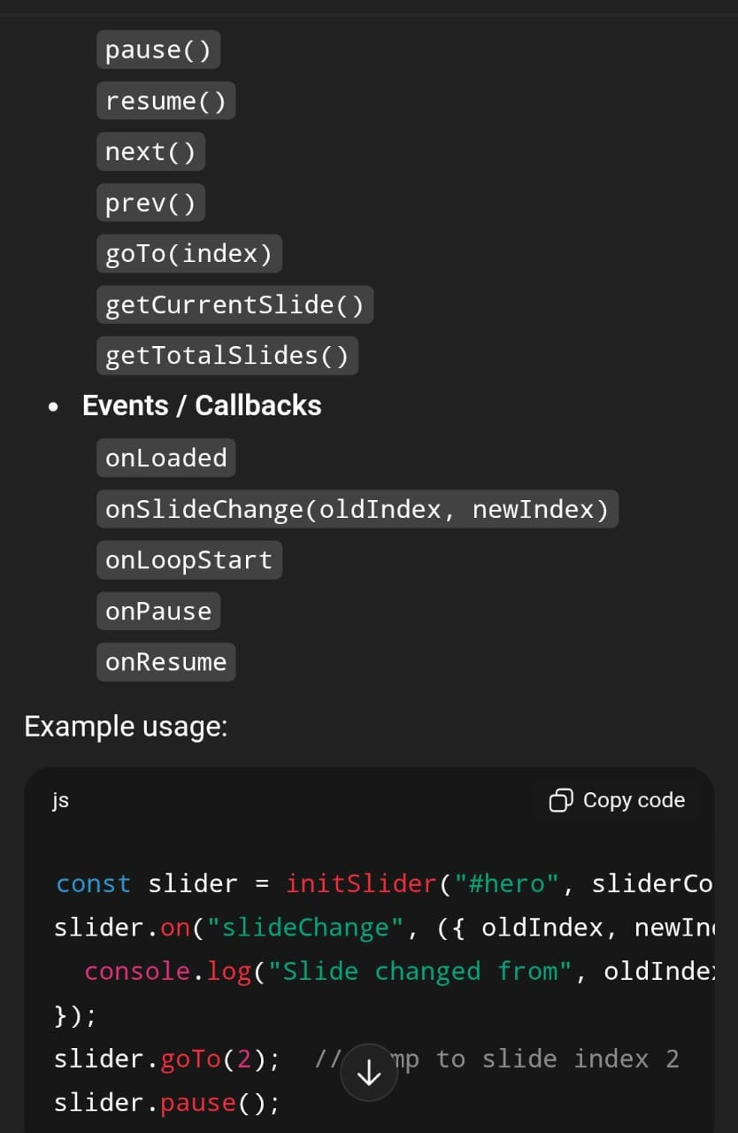

### Challenges & Solutions

#### 1. Challenge: Smooth Transition Animations

**Problem:**  
Ensuring smooth and visually appealing slide transitions without flickering or delay between images.

**Solution:**

* Utilized CSS transitions and keyframe animations for seamless fade and slide effects.
* Implemented requestAnimationFrame() for optimized frame rendering.
* Reduced animation duration for better user experience and responsiveness.

#### 2. Challenge: Image Preloading & Lazy Loading

**Problem:**  
Delays in image loading caused blank slides or stuttering during transitions.

**Solution:**

* Used JavaScript preloading techniques to load the next image before transition.
* Implemented lazy loading to reduce initial page load time.
* Optimized image file sizes using compression tools (like TinyPNG or WebP format).

#### 3. Challenge: Responsive Layout

**Problem:**  
The slider design did not adapt properly across various screen sizes and devices.

**Solution:**

* Applied responsive design principles using CSS Flexbox and Grid.
* Used relative units (%, vw, vh) for width and height to ensure adaptability.
* Tested on multiple devices and browsers to ensure consistency.

#### 4. Challenge: Performance Optimization

**Problem:**  
Lagging transitions and memory usage issues when handling large image sets.

**Solution:**

* Optimized DOM updates by minimizing reflows and repaints.
* Used image caching and efficient event listeners.
* Deferred non-critical JavaScript for faster load times.

#### 5. Challenge: Cross-Browser Compatibility

**Problem:**  
Some animation effects and layout styles did not behave consistently across browsers.

**Solution:**

* Used vendor prefixes for CSS animations (e.g., -webkit-, -moz-).
* Tested slider on major browsers like Chrome, Firefox, Edge, and Safari.
* Ensured fallbacks for unsupported properties and used standard-compliant code.

### Final Submission (Repo + Deployed Link)

**GitHub Repository:** [https://github.com/Abish589/dynamic-image-slider.git]